Lab 7.1.6 - Use Wireshark to Examine Ethernet Frames Topology _ Windows version

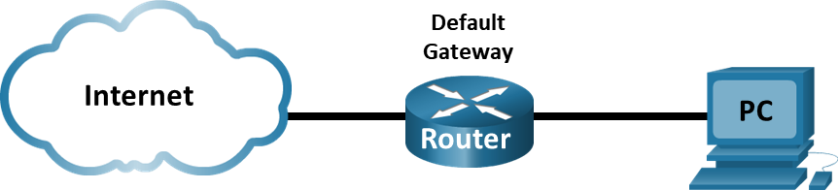

# Objectives

Part 1: Use Wireshark to Capture and Analyze ICMP Ethernet Frames

Part 2: Use Wireshark to Capture and Analyze ARP Ethernet Frames

# Background / Scenario

When upper layer protocols communicate with each other, data flows down the Open Systems Interconnection (OSI) layers and is encapsulated into a Layer 2 frame. The frame composition is dependent on the media access type. For example, if the upper layer protocols are TCP and IP and the media access is Ethernet, then the Layer 2 frame encapsulation will be Ethernet II. This is typical for a LAN environment.

When learning about Layer 2 concepts, it is helpful to analyze frame header information. In the first part of this lab, you will review the fields contained in an Ethernet II frame. In Part 2, you will use Wireshark to capture and analyze Ethernet II frame header fields for local and remote traffic.

# Required Resources

* **1 PC (Windows with internet access and with Wireshark installed) see previous Lab 3.7.1 on for instructions installing Wireshark**

# Instructions

* Enter your screenshots/answers below the items highlighted in blue and turn in the completed file without making any changes to the original content.
* This Lab cannot be completed using NetLab. Complete using a computer with Internet Access.
* Once the Lab is graded it cannot be resubmitted for a new grade.

## Part 1: Use Wireshark to Capture and Analyze ICMP Ethernet Frames

### Review the following Ethernet II header field descriptions and lengths.

| Preamble | Destination Address | Source Address | Frame Type | Data | FCS |
| --- | --- | --- | --- | --- | --- |
| 8 Bytes | 6 Bytes | 6 Bytes | 2 Bytes | 46 – 1500 Bytes | 4 Bytes |

### Examine the network configuration of the PC.

From a command prompt enter the **ipconfig /all** command and provide a screenshot of the output. (10 points)

.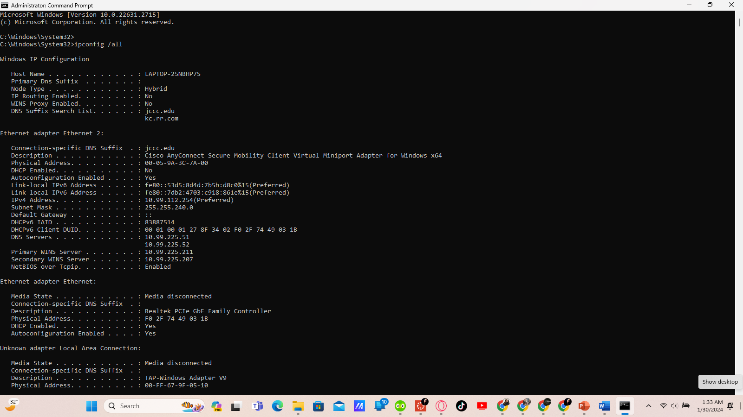

### Set the filter in Wireshark to display only ICMP traffic.

You can use the filter in Wireshark to block visibility of unwanted traffic. The filter does not block the capture of unwanted data; it only filters what you want to display on the screen. For now, only ICMP traffic is to be displayed.

In the Wireshark **Filter** box, type **icmp**. The box should turn green if you typed the filter correctly. If the box is green, click **Apply** (the right arrow) to apply the filter.

### From the command prompt window, ping the default gateway of your PC.

Open a Windows command prompt.

Close Windows command prompt.

### Stop capturing traffic on the NIC.

Click the **Stop Capturing Packets** icon to stop capturing traffic.

Provide a screenshot of Wireshark showing the captured **ICMP** frames. (10 points)

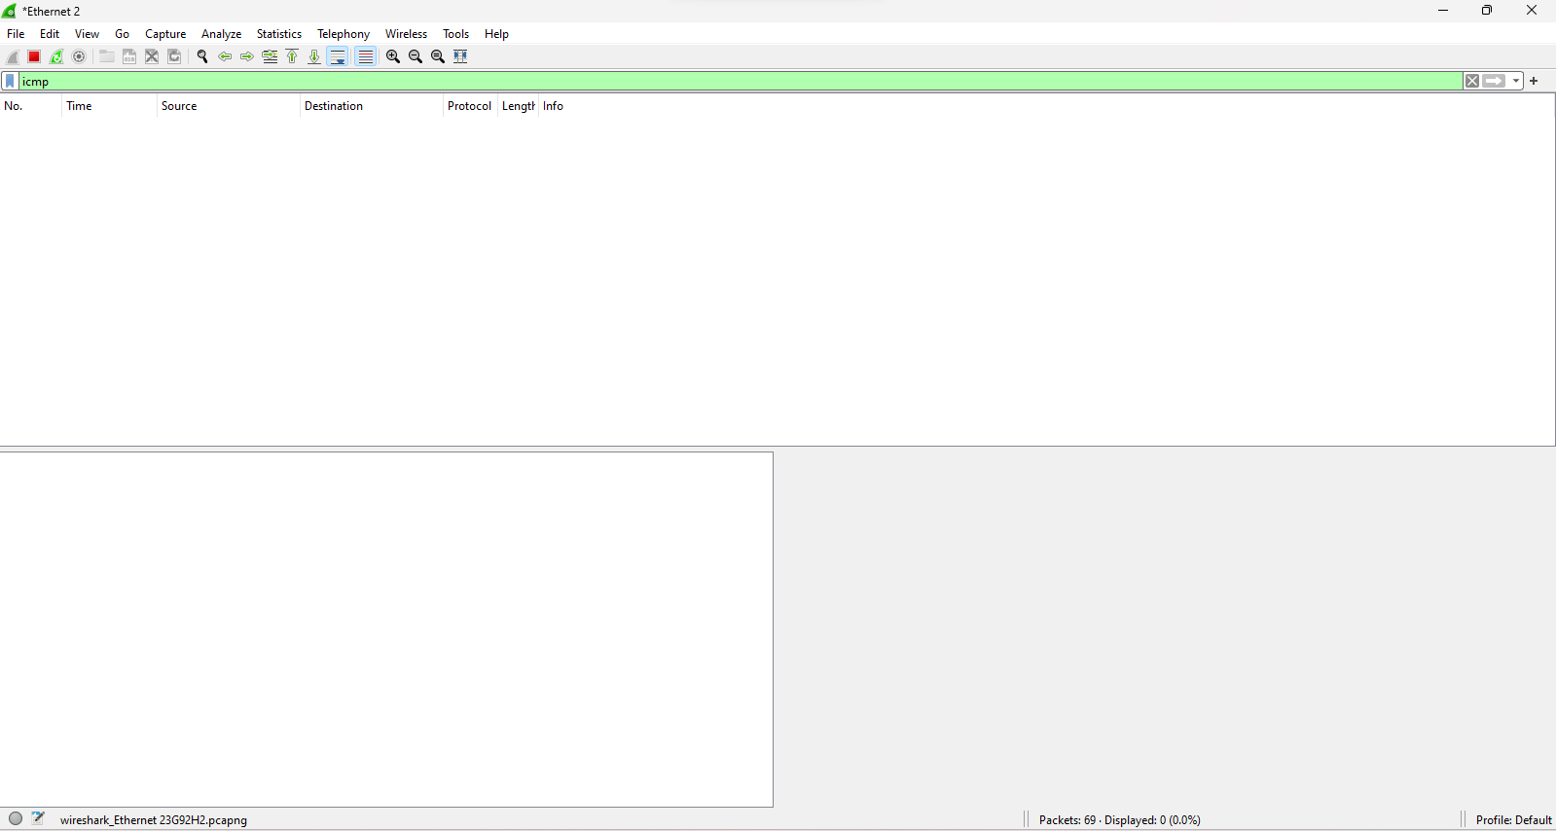

### Examine the first Echo (ping) request in Wireshark.

The Wireshark main window is divided into three sections: the packet list pane (top), the **Packet Details** pane (middle), and the **Packet Bytes** pane (bottom or on the side). If you selected the correct interface for packet capturing previously, Wireshark should display the ICMP information in the packet list pane of Wireshark.

* + - 1. In the packet list pane (top section), click the first frame listed. You should see the **Echo (ping) request** under the **Info** heading. The line should now be highlighted.
      2. Examine the first line in the packet details pane (middle section). This line displays the length of the frame.
      3. The second line in the packet details pane shows that it is an Ethernet II frame. The source and destination MAC addresses are also displayed.

#### Questions:

What is the MAC address of the PC NIC? (3 points)

E4:44:32:B7:A2:21

What is the default gateway’s MAC address? (3 points)

T172.23.64.1.

* + - 1. You can click the greater than (>) sign at the beginning of the second line to obtain more information about the Ethernet II frame.

#### Question:

What type of frame is displayed? (3 points)

0x0800 or an IPv4 frame type your answers here.

* + - 1. The last two lines displayed in the middle section provide information about the data field of the frame. Notice that the data contains the source and destination IPv4 address information.

#### Questions:

What is the source IP address? (3 points)

IPv6swers here.

What is the destination IP address? (3 points)

192.168.132.1your answers here.

* + - 1. You can click any line in the middle section to highlight that part of the frame (hex and ASCII) in the **Packet Bytes** pane (bottom or side section). Click the **Internet Control Message Protocol** line in the middle section and examine what is highlighted in the **Packet Bytes** pane.

#### Question:

What do the last two highlighted octets spell? (3 points)

Type your answers here.

* + - 1. Click the next frame in the top section and examine an Echo reply frame. Notice that the source and destination MAC addresses have reversed, because this frame was sent from the default gateway router as a reply to the first ping.

#### Question:

What device and MAC address is displayed as the destination address? (5 points)

F8:ff:c2:25:30:d9your answers here.

### Capture packets for a remote host.

* + - 1. Click the **Start Capture** icon to start a new Wireshark capture. You will receive a popup window asking if you would like to save the previously captured packets to a file before starting a new capture. Click **Continue without Saving**.

Open a Windows command prompt.

* + - 1. In a command prompt window, ping [www.cisco.com](http://www.cisco.com).

Note: Windows may use IPv6 addresses when pinging remote hosts. To force Windows to use IPv4 addressing instead of IPv6 addressing, use the following syntax: ping -4 www.cisco.com

Close a Windows command prompt.

* + - 1. Stop capturing packets.
      2. Examine the new data in the packet list pane of Wireshark.

#### Questions:

In the first echo (ping) request frame, what are the source and destination MAC addresses?

**Source** (3 points):

**Destination** (3 points):

Type your answers here.

What are the source and destination IP addresses contained in the data field of the frame?

**Source** (3 points):

T

answers here.

**Destination** (3 points):

Type your answers here.

Compare these addresses from Step 7 above to the addresses you received in Step 6. The only address that changed is the destination IP address. Why has the destination IP address changed, while the destination MAC address remained the same? (10 points)

### Part 2: Examine Ethernet frames with ARP payload in a Wireshark capture.

ARP stands for address resolution protocol. ARP is a communication protocol that is used for determining the MAC address that is associated with the IP address. Enter **arp** in the Wireshark filter to view only frames with ARP payload.

Locate an arp broadcast frame like the one shown in the screenshot below:

Provide a screenshot like the one above. (10 points)

### Examine the Ethernet II header contents of an ARP broadcast request. Analyze one of the broadcast frames you captured to answer the following questions:

What is the destination IP address? (5 points)

What is the source MAC address of the sender? (5 points)

What is the Vendor ID (OUI - Organization Unique Identifier)? (5 points)

What is the NIC serial number of the sender MAC address? (5 points)

Type your answers here.

What is the type of the Ethernet frame? (5 points)

Type your answers here.

End of Document